Experiment - 2
Operating Systems Lab
Syeda Reeha Quasar
14114802719
6C7
AIM
Write a program to implement CPU scheduling for the shortest job first.

EXPERIMENT – 2

Aim:
Write a program to implement CPU scheduling for shortest job first.

Theory:
Shortest job first (SJF) or shortest job next, is a scheduling policy that selects the waiting process with the smallest execution time to execute next. SJN, also known as Shortest Job Next (SJN), can be preemptive or non-preemptive.

Characteristics of SJF Scheduling:
- Shortest Job first has the advantage of having a minimum average waiting time among all scheduling algorithms.
- It is a Greedy Algorithm.
- It may cause starvation if shorter processes keep coming. This problem can be solved using the concept of aging.
- It is practically infeasible as Operating System may not know burst times and therefore may not sort them. While it is not possible to predict execution time, several methods can be used to estimate the execution time for a job, such as a weighted average of previous execution times.
- SJF can be used in specialized environments where accurate estimates of running time are available.

Algorithm:
- Sort all the processes according to the arrival time.
- Then select that process that has minimum arrival time and minimum Burst time.
- After completion of the process make a pool of processes which after till the completion of the previous process and select that process among the pool which is having minimum Burst time.

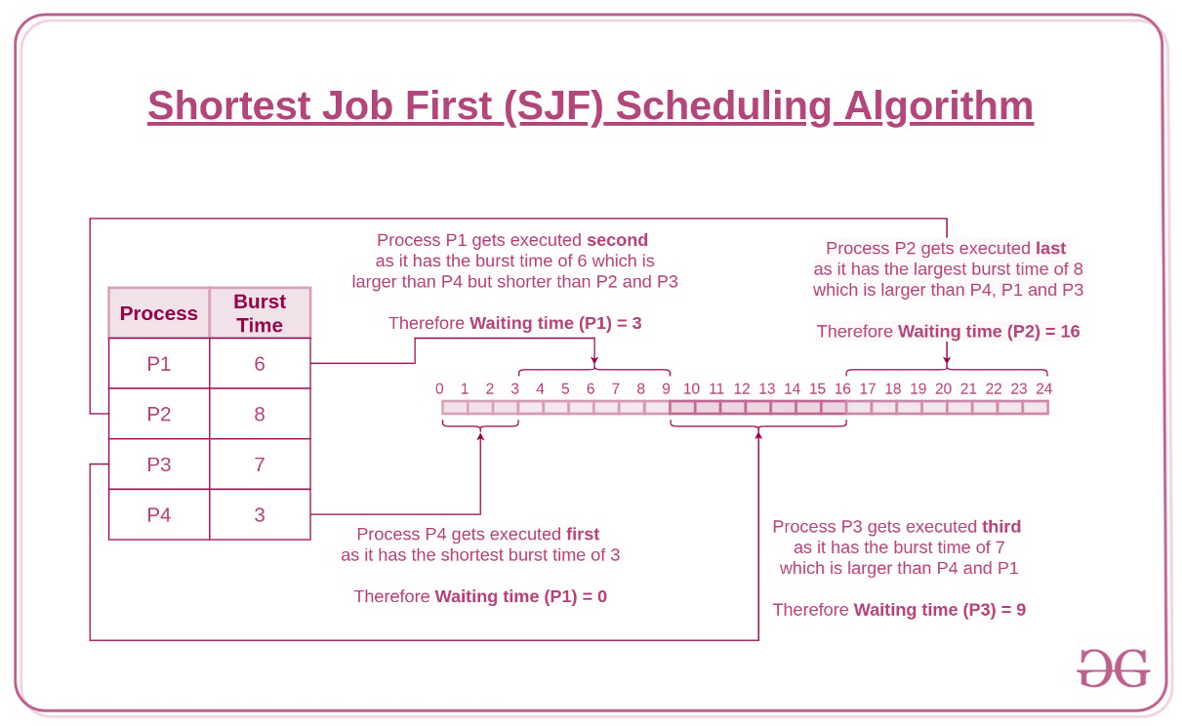

- Completion Time: Time at which process completes its execution.
- Turn Around Time: Time Difference between completion time and arrival time.
Turn Around Time = Completion Time – Arrival Time
- Waiting Time(W.T): Time Difference between turn around time and burst time.
Waiting Time = Turn Around Time – Burst Time

Source Code:

#! /bin/bash

function shortestjobfirst {
#Initializing Bash variables
awt=0
totalwt=0
totaltat=0
atat=0
temp=0
declare -a wt
declare -a tat
#sorting burst time in ascending order using selection sort
for ((i = 0; i<${number-1}; i++))
do

for((j = 0; j<${number-i-1}; j++))
do

if [[ "${Btime[$j]}" -gt "${Btime[$j+1]}" ]];
then
# swaping Burst time array
temp=${Btime[$j]};
Btime[$j]=${Btime[$j+1]};
Btime[$j+1]=$temp;

#swaping process positon
temp=${p[$j]};
p[$j]=${p[$j+1]};
p[$j+1]=$temp;
fi
done
done
echo -e "Process\t Burst Time \tWaiting Time\tTurnaround Time"
for ((i=1;i<=number;i++))
do
wt[i]=0;
tat[i]=0;
for ((j=0;j<i;j++))
do
wt[i]="$((wt[i]+Btime[j]))" #calculate waiting time
done

totalwt="$((totalwt+wt[i]))" #calculate total waiting time
tat[i]="$((Btime[i]+wt[i]))" #calculate turnaround time
totaltat="$((totaltat+tat[i]))" #calculate total turnaround time
echo -e "${p[i]}\t\t ${Btime[i]}\t\t ${wt[i]}\t\t\t${tat[i]}"
done

awt=$(echo 'scale=2;' "$totalwt" / "$number" | bc -l) #calculate average waiting time
atat=$(echo 'scale=2;' "$totaltat" / "$number" | bc -l) #calculate average turnaround time
echo -e "\n"
echo "Total waiting time =" "$totalwt"
echo "Average waiting time =" "$awt"
echo "Total Turnaround Time =" "$totaltat"
echo "Average Turnaround Time =" "$atat"
}

#Accepts user input for Number of Processes and Input Validation
echo "Enter the number of processes -- "
read -r number
while [[ "$number" -le 1 ]] || [[ -z "$number" ]]
do
echo "Error: Input valid number of processes or Input cannot be blank"
echo "Please try again."
echo "Enter the number of processes -- "
read -r number
done

declare -a Btime
declare -a p
declare -a rem_bt

#Accepts user input for Burst Time and Input Validation
for (( i=1; i<=number; i++ ))
do

echo "Enter Burst Time for Process -- $i"
read -r "Btime[i]"

while [[ "${Btime[i]}" -lt 1 ]] || [[ -z "${Btime[i]}" ]]
do
echo "Error: Input valid burst time for the process or Inputs cannot be blank"
echo "Please try again."
echo "Enter Burst Time for Process -- $i"
read -r "Btime[i]"
done
p[i]=$i #contains process number
rem_bt[i]=${Btime[i]} #remaining process
done

echo -e "CPU burst Time for processes in nano second --" "${Btime[@]}"
echo -e "Process Number for CPU burst time --" "${p[@]}"
echo ""
echo "Calculation for Shortest Job first for processes entered are as follows: "
shortestjobfirst

Output:
